VAST Decoder Box Smart Card Location
For UEC, HUMAX and SatKing decoders

Smart Card number is located above the barcode on the back of the card.

When reinserting the smart card please ensure the chip if facing down and the arrow is on top pointing forward into the decoder.

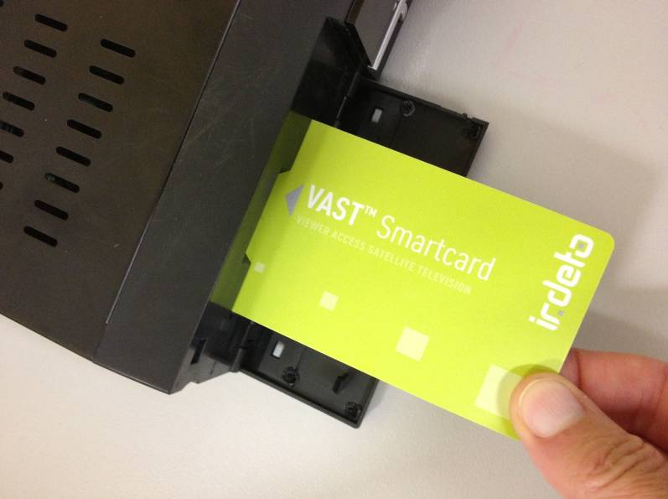

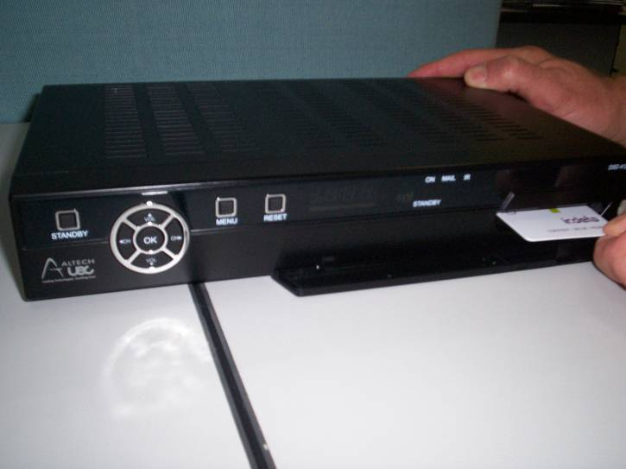
UEC DSD4121
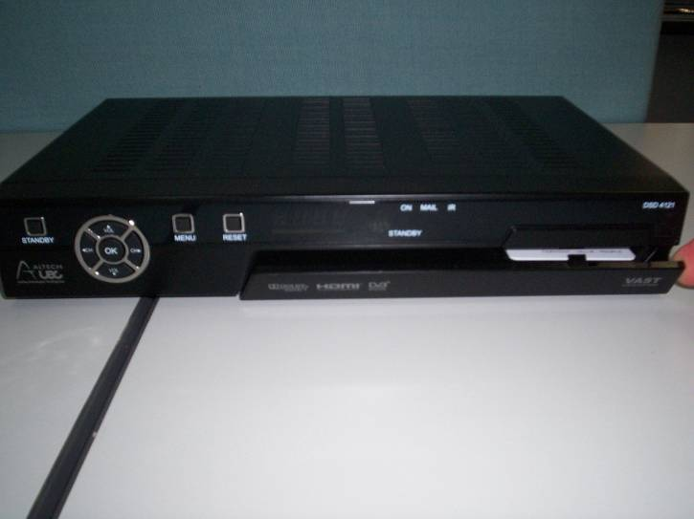
UEC DSD4121 RV

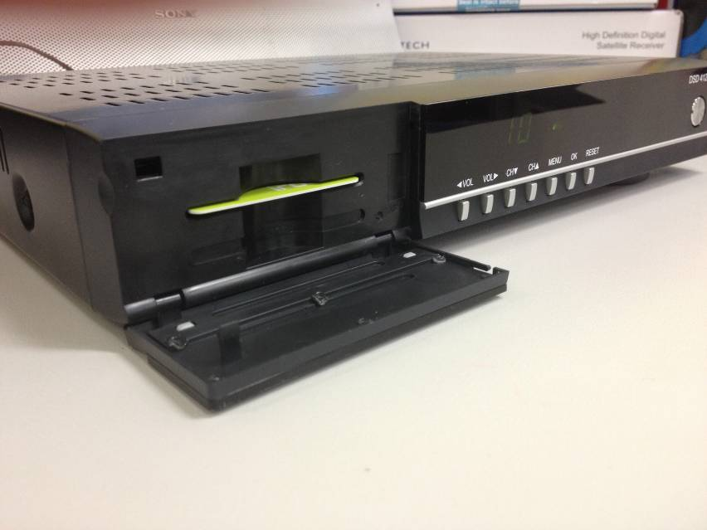

UEC DSD4639

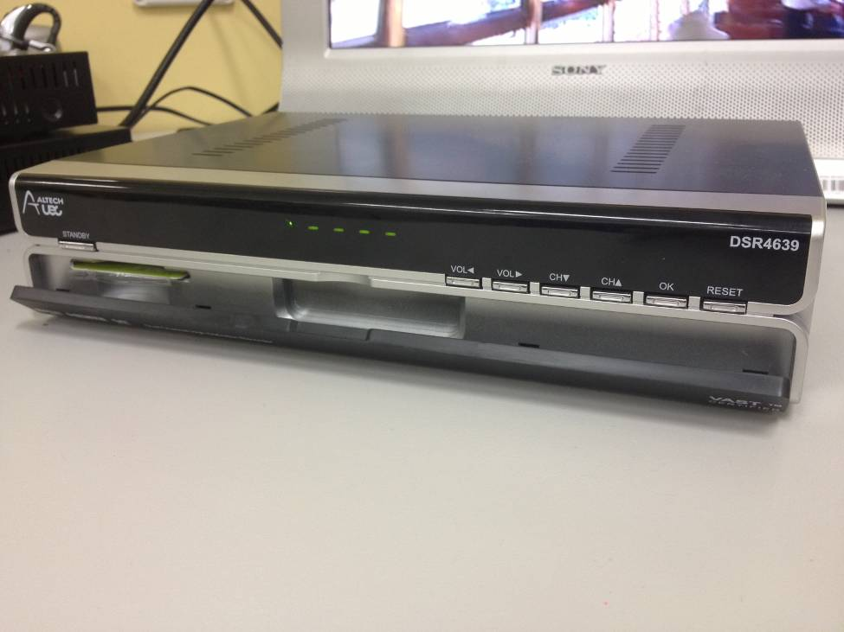
SatKing DVBS2-800CA

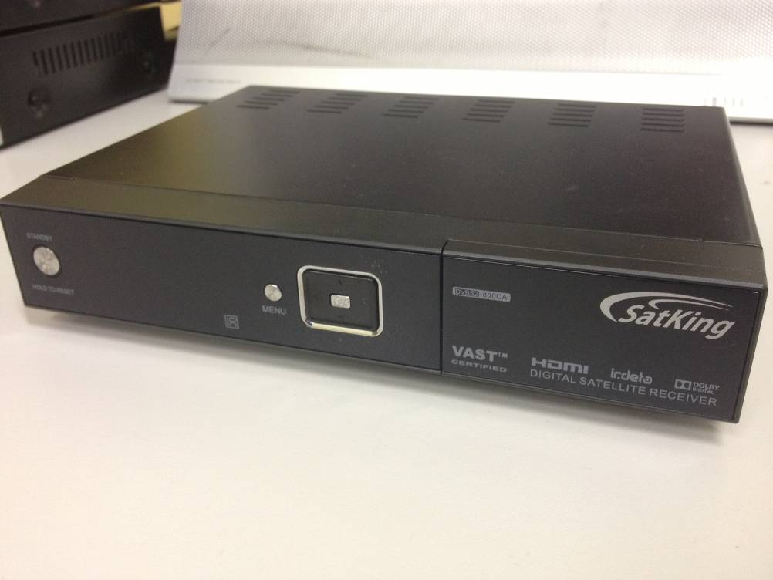

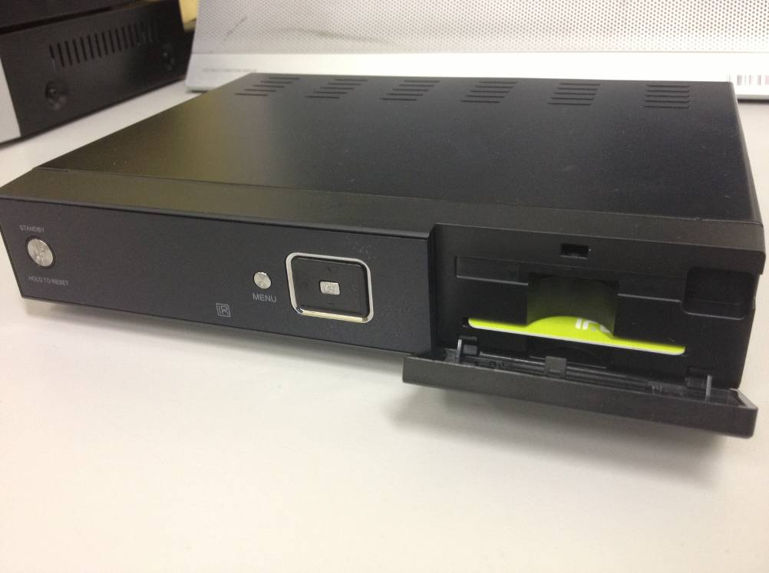
HUMAX HDR-1003S

